**Hao Zhong, Baichuan Lu**

**CS 579 Project 4**

**Problem 1**

Code:

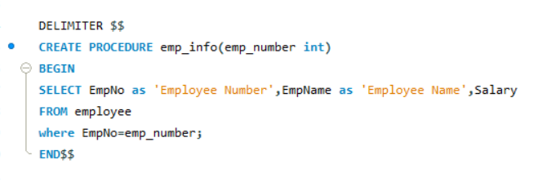

**Result:**

Call emp_info(112233);

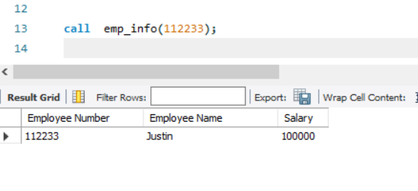

**Problem 2**

Code:

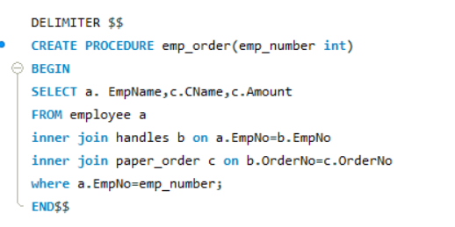

**Result:**

Call emp_order(112233);

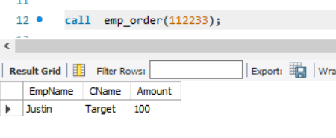

**Problem 3**

Code:

**Result:**

Select get_phone(‘CVS’,1)

**Problem 4**

Code:

**Test:**

**Violates the constraint:**

Code:

insert into handles values (778899, 123); /* violates the constraint */

Result:

**No Violations:**

Code:

insert into handles values (112233, 789); /* no violation */

Result:

**Problem 5**

Code:

**Test**

**Violate the constraint:**

Code:

Insert Into suborder Values (123, '003', '2007-04-01', '2007-03-01', 'Target', 3);

/* violates the constraint */

Result:

**No violations:**

Code:

Insert Into suborder Values (789, '003', '2008-03-09', '2008-03-10', 'Walmart', 3);

/* no violation */

Result: